Undergraduate student workshop 2023 Sat Nov 4 (7 am) to Sun Nov 5 (7 pm)
台灣離岸風電之未來展望
Future Offshore Wind for Taiwan
在未來三十年間，台灣所面臨一個關鍵性的工程挑戰將會是海上風電的永續發展。 為了展望這個未來及其發展如何影響許多人，其中包括身為未來工程師的你，國立台灣大學和國立中興大學土木工程系在本學期11月4-5日(週六和週日)籌辦了一次免費的周末工作坊，專門探討海上風電。 這個跨學科、國際化、中英文雙語研討會的主要招募對象是來自國立台灣大學和國立中興大學工程學院大學部一年級的學生，包括台灣學生和國際學生。 該計劃將包括第一天(週六)參觀目前營運中的離岸風電運營和供應鏈現場，以及第二天（週日）由混合學生團隊進行的設計挑戰。
Over the next thirty years, a key engineering challenge for Taiwan will be the sustainable development of offshore wind energy. To envision this future, and how developments could affect many people including you as a future engineer, the NTU and NCHU Civil Engineering Departments organize this semester an all-expenses-paid, week-end workshop devoted to offshore wind. The interdisciplinary, international, and bilingual English/Chinese workshop is targeted at first and second year undergraduates, including Taiwanese and international students, from the Colleges of Engineering of NTU and NCHU. The program will include visits to currently active offshore wind operation and supply chain sites (Saturday), and a design challenge to be pursued in mixed student teams (Sunday).
對於中興大學的學生，工作坊的時程表如下：
For NTU students, the program of the workshop will be as follows:
11月4日(週六) SATURDAY NOV 4
10:30: 於土木環工大樓集合搭車
10:30: Departure by bus from Civil Engineering building at NCHU.
12:00: 抵達台中港，與台大成員共同參觀天力風電葉片工廠。
12:00: Arrival at Port of Taichung to visit the blades yard of Tien Li / Vestas.
12:40-13:40：學生團隊組成，並與台灣大學師生共進午餐。
12:40-13:40: Student teams formation and lunch with NTU students at Port of Taichung.
14:00-16:00：共同參觀台中港西門子公司風電構件組裝現場。
14:00-16:00: Joint visit of Siemens Gamesa nacelle assembly site at Port of Taichung.
16:30-18:00：共同參觀台中市風電場運控中心
16:30-18:00: Joint visit of wind farm operation and control center in City of Taichung.
18:00-19:30：在國立中興大學校園附近的學生團隊用晚餐
18:00-19:30: Dinner in student teams near NCHU campus
19:30-21:00：在中興大學校學內，學生團隊共同設想離岸風電的未來影響。
19:30-21:00: At NCHU, work in student teams on envisioning the future impacts of offshore wind.
11月5日(週日) Sun Nov 5,
上午 9:00 至 12:00：在國立中興大學內，學生團隊參與離岸風電設計挑戰。
9:00 am-12:00: At NCHU, work in student teams on offshore wind design challenge.
12:30-14:00:於國立中興大學用午餐
12:30-14:00: Lunch in student teams at NCHU campus.
14:00-16:00：學生團隊展示其設計和專家反饋。
14:00-16:00: Student team design presentations and expert feedback.
16:30:研討會結束並送行台大師生
16:30: End of the workshop and send off of NTU visitors.
​報名：要報名參加研討會，有興趣的中興大學學生請在2023/10/26 20:00之前填寫連結 https://forms.gle/ZYx9VqjpMnobHE4A8 上的線上表格,為了保險和辦理台中港入港證，並請提供包括 [身分證字號/出生年月日/手機號碼] 在內的完整資訊來申請，然後將提供通知和進一步的實用資訊。
名額: 十位正取、十位備取，依報名順序決定。
To sign up: To sign up for the workshop, interested NCHU students are invited to apply by completing the online form at link https://forms.gle/ZYx9VqjpMnobHE4A8 with complete information including [your ARC/Passport copy/cellphone no.], before the final deadline 2023/10/26 20:00. Notification and further practical information will then be provided.
Workshop organizers: Department of Civil Engineering, NTU and NCHU.
Sponsors: College of Engineering, NTU and NCHU, and Ministry of Education NEEMEC Project
Contact: In Civil Engineering Department, NTU, TA in charge of the workshop is Ms. I-Ying LI (李怡穎), Email: <wing@ntu.edu.tw>, Office phone(02) 3366-4305, In Civil Engineering Department, NCHU, TA in charge of the workshop is Mr. CHUN-YU KAN (甘峻宇), Email: <kan9765013@gmail.com>, Office phone(04) 2287-0437#104.
注意: 基於安全上的考量，參訪台中港時須攜帶身分證正本供港警查驗，並且須自備符合BSMI規範之專業工作鞋(亦即鋼頭鞋，可以參考https://shopee.tw/product/384892018/3280495501?d_id=850a2&utm_content=3zDtUPkzx17pB5USxosU7ALSNzTZ)，若不便攜帶&自行購買，可於申請單備註鞋子尺碼一同購買，此外會提供工地安全帽、反光背心。
Note: For safety reasons, when visiting Taichung Port, you must bring your porr for inspection by the port police, and you must bring your own professional work shoes that comply with BSMI standards( please refer to https://shopee.tw/product/384892018/3280495501?d_id=850a2&utm_content=3zDtUPkzx17pB5USxosU7ALSNzTZ )，If it is not convenient to bring & purchase by yourself, you can specify the shoe size on the application form and purchase together. In addition, construction site safety helmets and reflective vests will be provided.

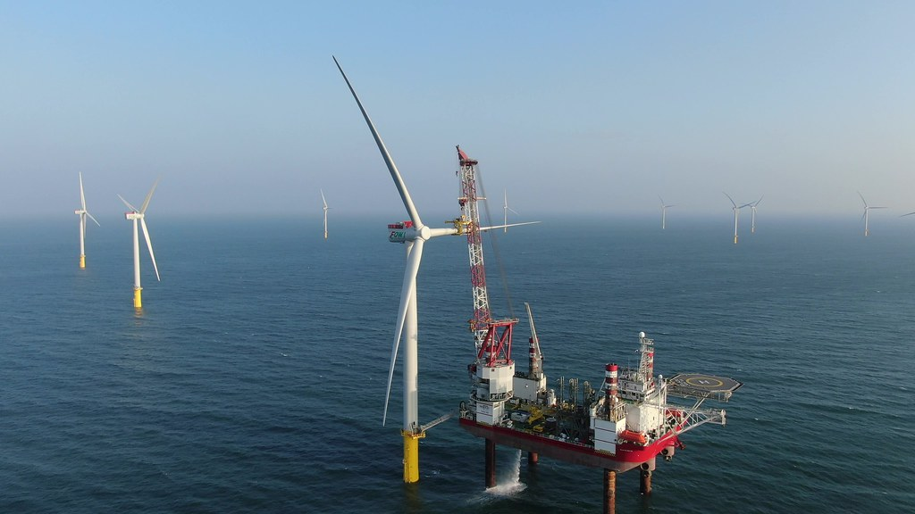 | 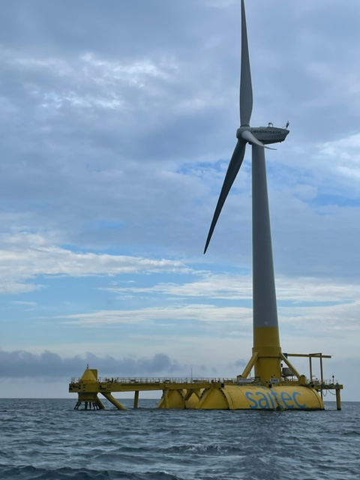
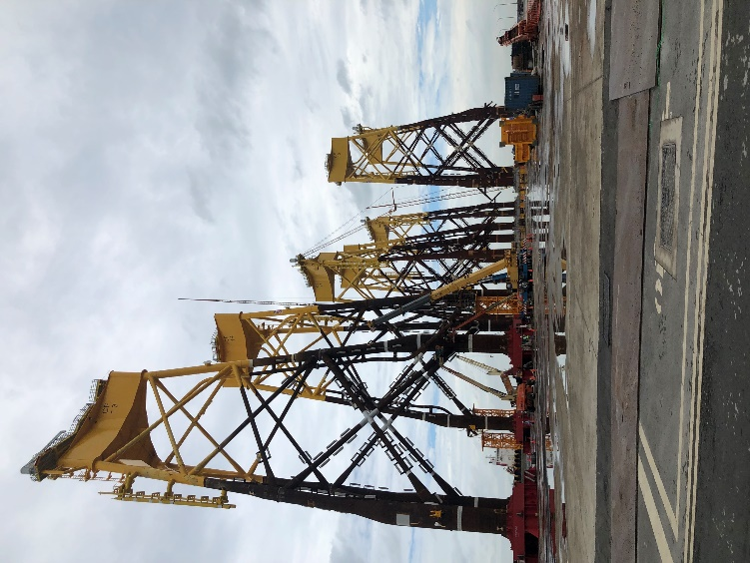
Visuals sources: Formosa I / Dean M.-H. Chiang, NTU-CoE (left), Prof. H. S.-H. Yang, NTU-ESOE (right).

