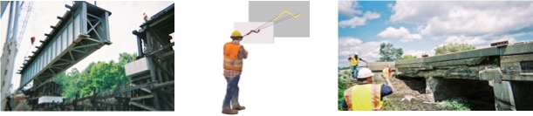

**Advanced Inspections of Structures Using Augmented Reality**

**Fernando Moreu,** Associate Professor, Department of Civil, Construction and Environmental Engineering University of New Mexico, Albuquerque, NM (USA)

Director, Smart Management of Infrastructure Laboratory <http://smilab.unm.edu/>

**Abstract:**

In recent decades, Structural Health Monitoring (SHM) research has used field deployments and signal processing that transform decisions of engineers and/or stakeholders. In this context, decision-makers are in general using data collected in the field remotely, and sometimes processed by others, in the cloud, or using computer models. If users or managers would be able to access structural data related to safety or damage in the field directly, they could transform decisions in real-time. This presentation summarizes new work on SHM decisions exploring the concept of new human-machine interfaces associated with augmented reality. This presentation summarizes work in human-in-the-loop with application on real-time computer vision, robot enabled access to structural inspections, and new UAV structural inspection frameworks with practical applications in the field.

**Bio:**

**Fernando Moreu** is an Associate Professor at the Department of Civil, Construction, and Environmental Engineering (CCEE) at the University of New Mexico (UNM). He holds courtesy appointments in the Departments of Electrical & Computer Engineering, Mechanical Engineering, and Computer Science at UNM. He is the founder and director of the Smart Management of Infrastructure Laboratory (SMILab). Prof. Moreu’s research interests include structural dynamics and control, structural health monitoring, wireless smart sensor networks, cyber-physical systems, computer vision, augmented reality, unmanned aerial systems, bridge engineering, and aerospace operations. Prof. Moreu received his MS and PhD degrees in structural engineering from the University of Illinois at Urbana-Champaign (2005 and 2015, respectively). Prof. Moreu is the lead PI of a multidisciplinary team in the NSF Civic Innovation Challenge. In 2019 and 2021, he received the CCEE Stamm Teacher and Researcher of the Year award, respectively. He was the 2022 outstanding junior faculty researcher award at the UNM School of Engineering. Prof. Moreu’s projects are funded by the DOE, NSF, ONR, NAS, US DOT, TRB, New Mexico Space Grant Consortium, and the commercial sector. He is a member of ASCE, ASME, ISHMII, ASNT, and AREMA, and a registered Professional Engineer since 2010.

